Custom MapReduce with Hadoop Streaming for Sales Data Analysis

1. Objective
To analyze a large sales dataset using Hadoop Streaming by implementing custom Python Mapper and Reducer scripts. The experiment demonstrates city-wise sales analysis, monthly sales trends, product quantity analysis, and visualization of results using Hadoop MapReduce.

2. Procedure

Part 1: Generate Sales Dataset
- Create a Python script (generate_sales.py) to generate 50,000 sales records.
- Execute the script and store the output in sales_data.csv.
- Verify the dataset using:
Verify the dataset using:
ls -lh sales_data.csv
wc -l sales_data.csv
head -5 sales_data.csv

Part 2: Create Mapper for City Sales
- Create mapper_city_sales.py.
- Read each sales record.
- Extract city and calculate total sales amount (price × quantity).
- Emit output as:
Emit output as:
City TotalSales

Part 3: Create Reducer for City Sales
- Create reducer_city_sales.py.
- Aggregate sales values for each city.
- Count the number of transactions.
- Produce final city-wise sales summary.

Part 4: Test Locally
Execute:
head -20 sales_data.csv | python3 mapper_city_sales.py | sort | python3 reducer_city_sales.py

Verify the output before running on Hadoop.

Part 5: Run Hadoop Streaming Job
Create HDFS directories:
hdfs dfs -mkdir -p /user/$USER/sales/input
hdfs dfs -mkdir -p /user/$USER/sales/output

Upload dataset:
hdfs dfs -put sales_data.csv /user/$USER/sales/input/

Run Hadoop Streaming:
hadoop jar $HADOOP_HOME/share/hadoop/tools/lib/hadoop-streaming-*.jar \
-input /user/$USER/sales/input/sales_data.csv \
-output /user/$USER/sales/output \
-mapper "python3 mapper_city_sales.py" \
-reducer "python3 reducer_city_sales.py" \
-file mapper_city_sales.py \
-file reducer_city_sales.py

Part 6: Analyze Results
Download results:
hdfs dfs -get /user/$USER/sales/output/part-00000 city_sales_results.txt

Find top cities:
cat city_sales_results.txt | sort -t$'\t' -k2 -rn | head -5

Calculate average transaction value:
cat city_sales_results.txt | awk -F'\t' '{avg = $2/$3; print $1, avg}' | sort -k2 -rn

Part 7: Monthly Sales Analysis
- Create mapper_monthly_sales.py.
- Create reducer_monthly_sales.py.
- Run Hadoop Streaming job for monthly sales.
- View monthly sales trends.

Part 8: Product Quantity Analysis
- Create mapper_product_qty.py.
- Create reducer_product_qty.py.
- Execute Hadoop Streaming job.
- Identify top-selling products.

Part 9: Visualization
- Load output data using Pandas.
- Create a bar chart using Matplotlib.
- Save the chart as sales_analysis.png.

3. Source Code

A. Generate Dataset
import random
import datetime

products = ['Laptop', 'Mouse', 'Keyboard', 'Monitor',
'Headphones', 'Webcam', 'Printer', 'Scanner']

cities = ['Mumbai', 'Delhi', 'Bangalore', 'Chennai',
'Hyderabad', 'Pune', 'Kolkata', 'Ahmedabad']

customers = [f'CUST{str(i).zfill(5)}' for i in range(1, 1001)]

start_date = datetime.date(2024, 1, 1)
end_date = datetime.date(2024, 12, 31)
date_range = (end_date - start_date).days

for i in range(50000):
date = start_date + datetime.timedelta(days=random.randint(0, date_range))
product = random.choice(products)
price = round(random.uniform(100, 5000), 2)
city = random.choice(cities)
customer = random.choice(customers)
quantity = random.randint(1, 5)

print(f"{date},{product},{price},{city},{customer},{quantity}")

B. Mapper – City Sales
#!/usr/bin/env python3
import sys

for line in sys.stdin:
line = line.strip()

if not line:
continue

parts = line.split(',')

if len(parts) != 6:
continue

try:
price = float(parts[2])
city = parts[3]
quantity = int(parts[5])

total = price * quantity

print(f"{city}\t{total}")

except ValueError:
continue

C. Reducer – City Sales
#!/usr/bin/env python3
import sys

current_city = None
total_sales = 0
count = 0

for line in sys.stdin:
line = line.strip()

if not line:
continue

city, amount = line.split('\t')
amount = float(amount)

if city == current_city:
total_sales += amount
count += 1
else:
if current_city is not None:
print(f"{current_city}\t{total_sales:.2f}\t{count}")

current_city = city
total_sales = amount
count = 1

if current_city is not None:
print(f"{current_city}\t{total_sales:.2f}\t{count}")

D. Visualization Program
import pandas as pd
import matplotlib.pyplot as plt

df = pd.read_csv(
'city_sales_results.txt',
sep='\t',
header=None,
names=['City', 'TotalSales', 'TransactionCount']
)

df['AvgTransaction'] = (
df['TotalSales'] / df['TransactionCount']
)

plt.figure(figsize=(12, 6))

top_cities = df.nlargest(10, 'TotalSales')

plt.bar(
top_cities['City'],
top_cities['TotalSales'] / 1000000
)

plt.title('Top 10 Cities by Sales')
plt.xlabel('City')
plt.ylabel('Sales (Million ₹)')
plt.xticks(rotation=45)

plt.tight_layout()
plt.savefig('sales_analysis.png')

4. Screenshots
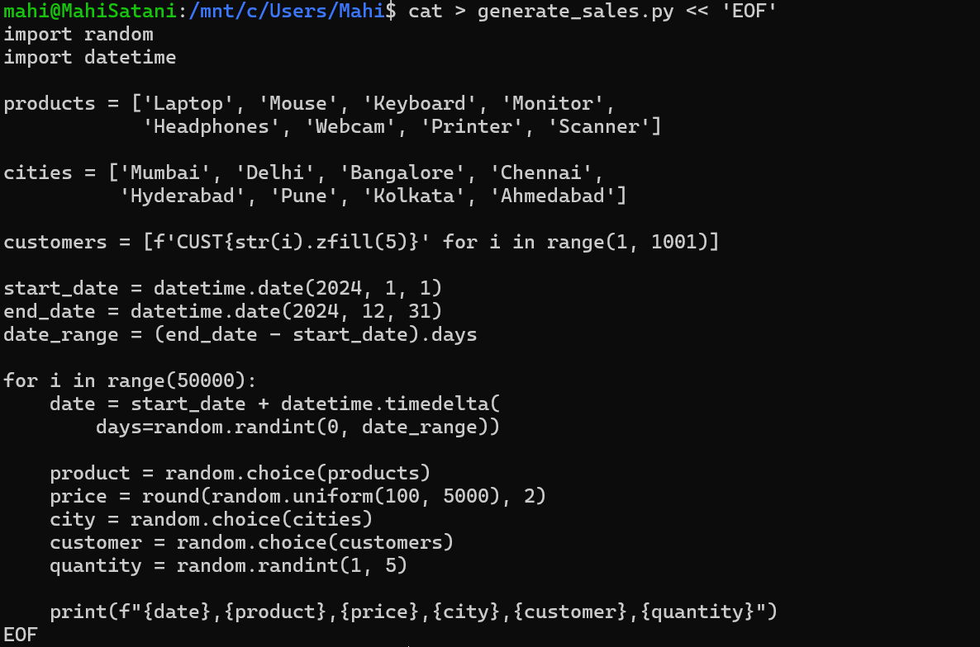
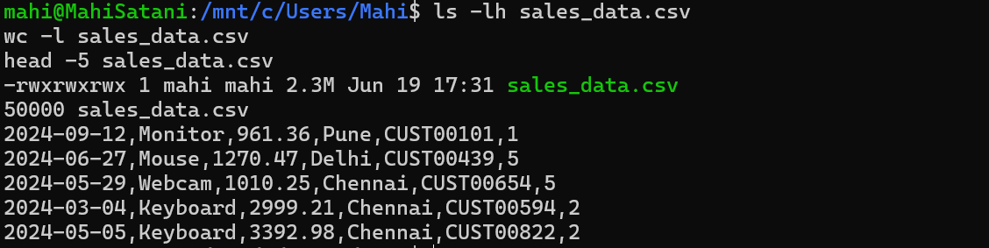
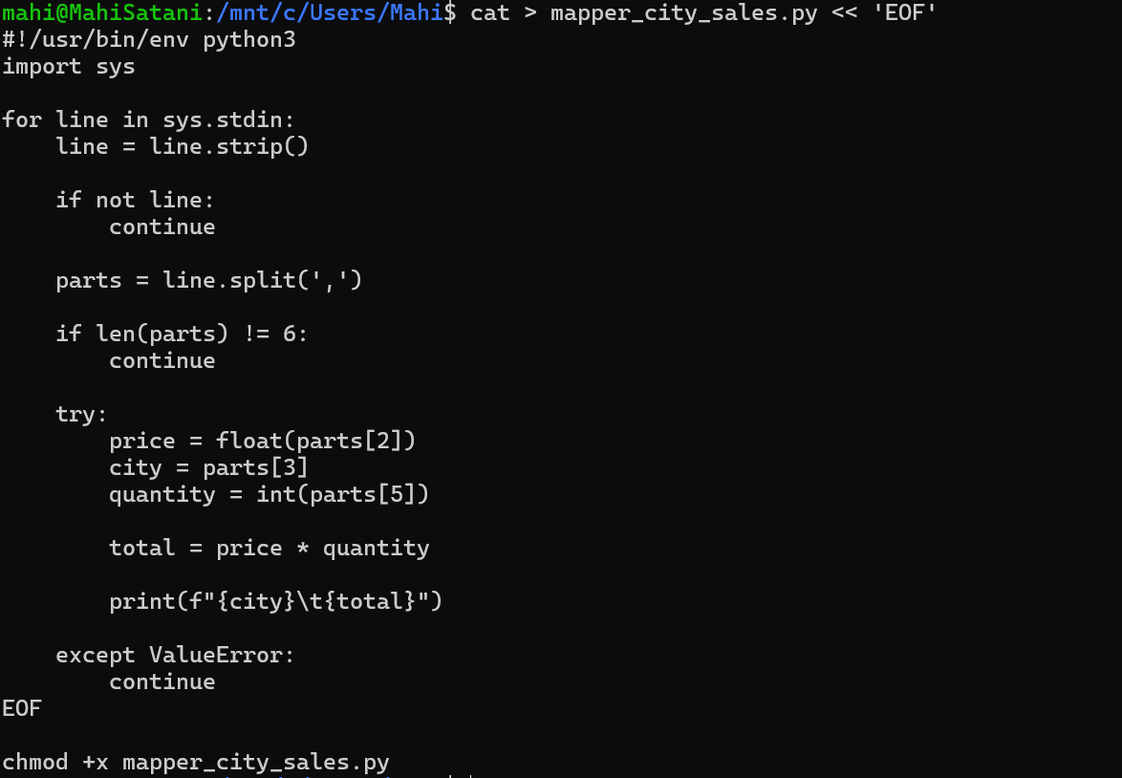
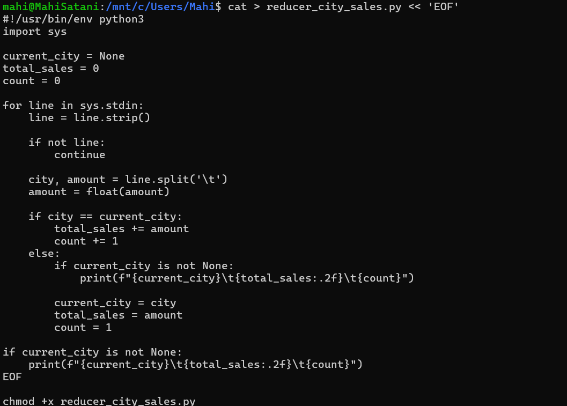
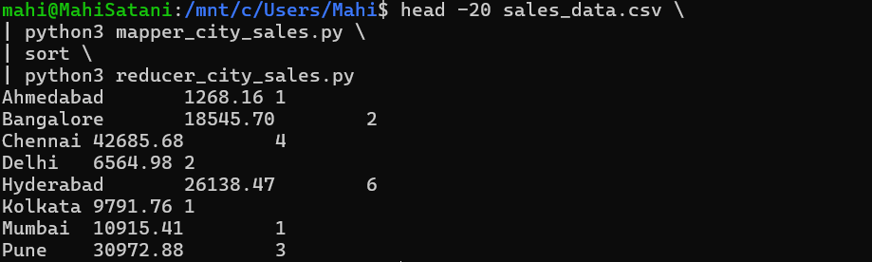
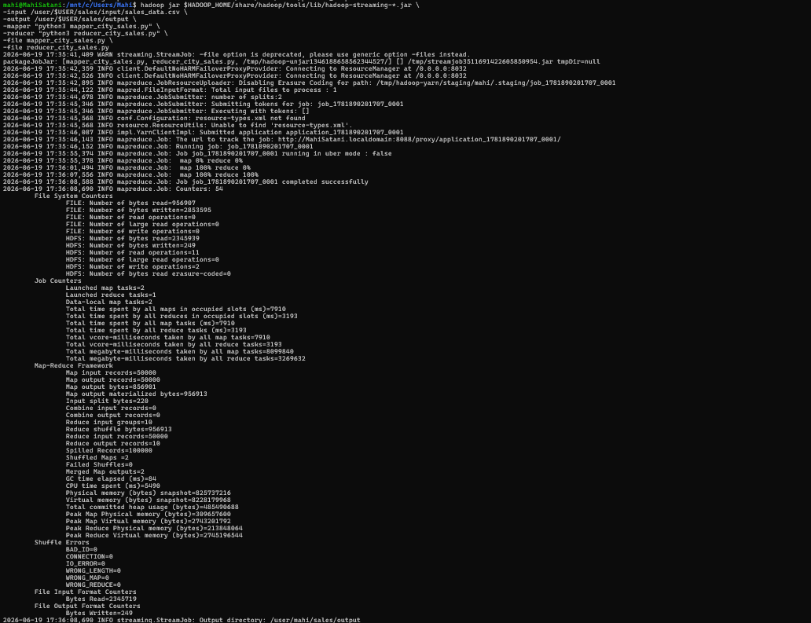
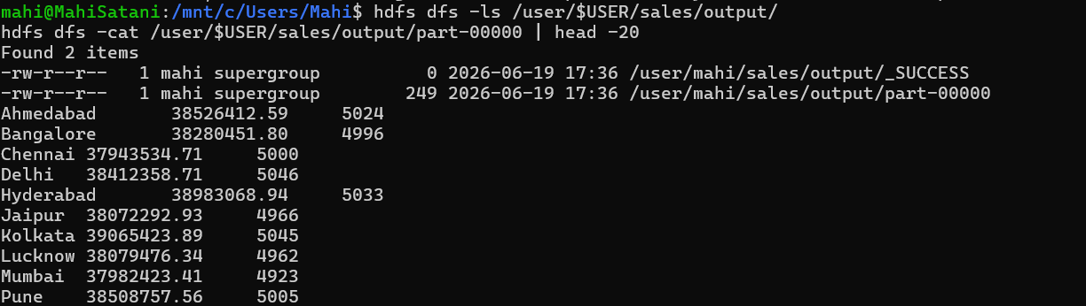
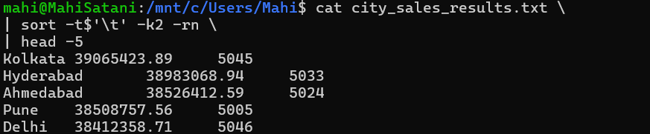
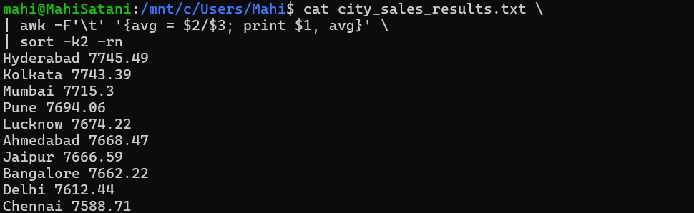
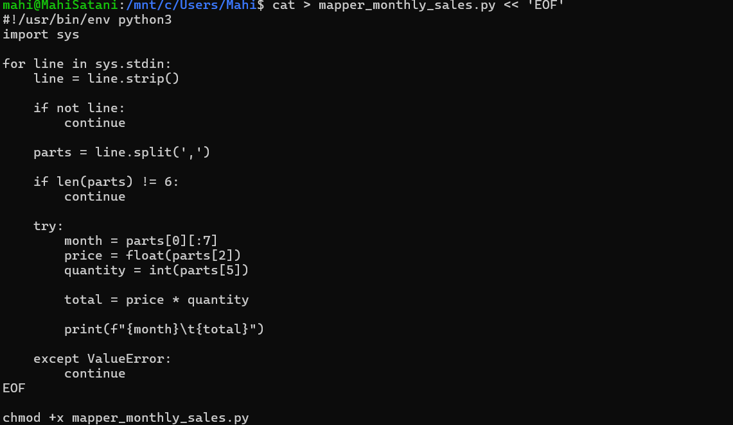
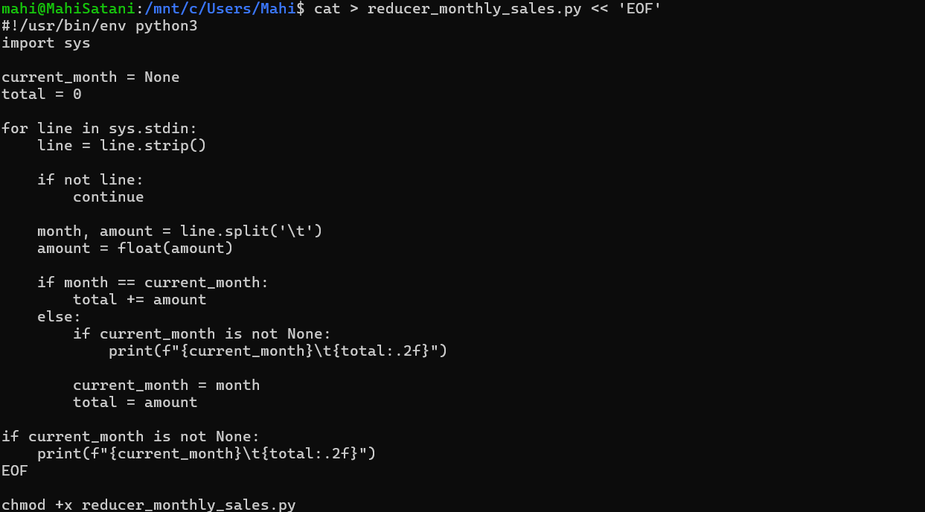
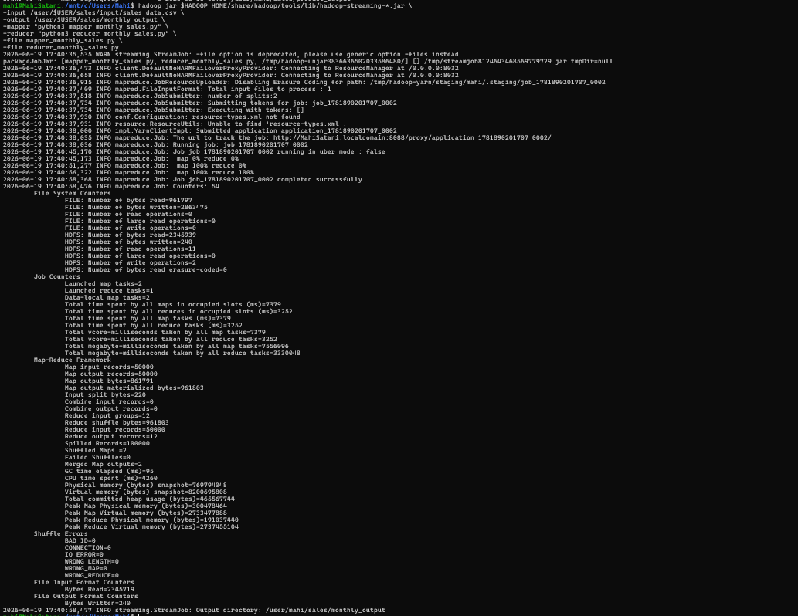
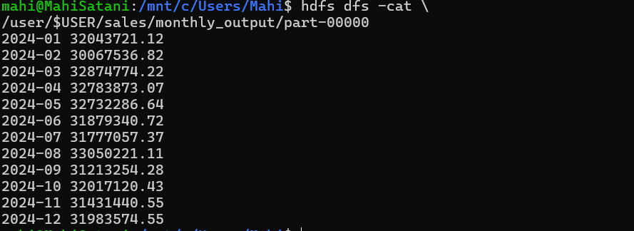
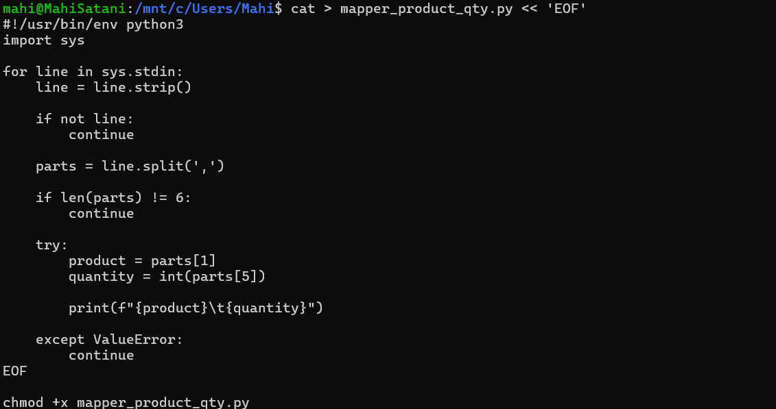
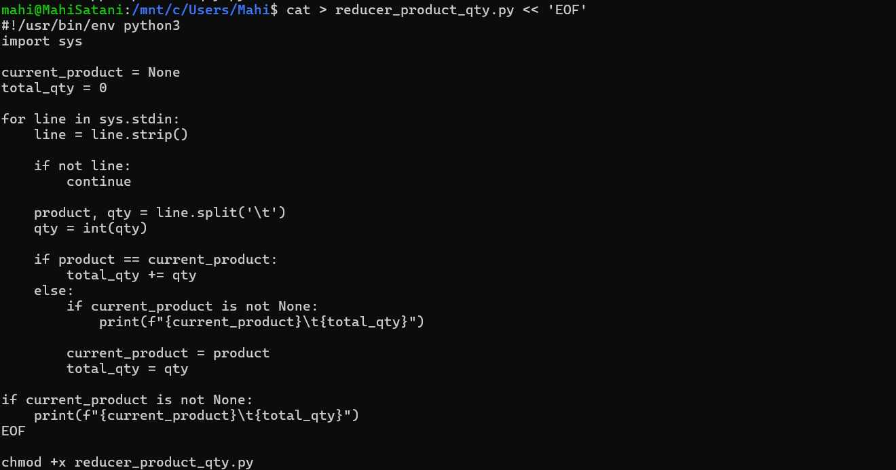
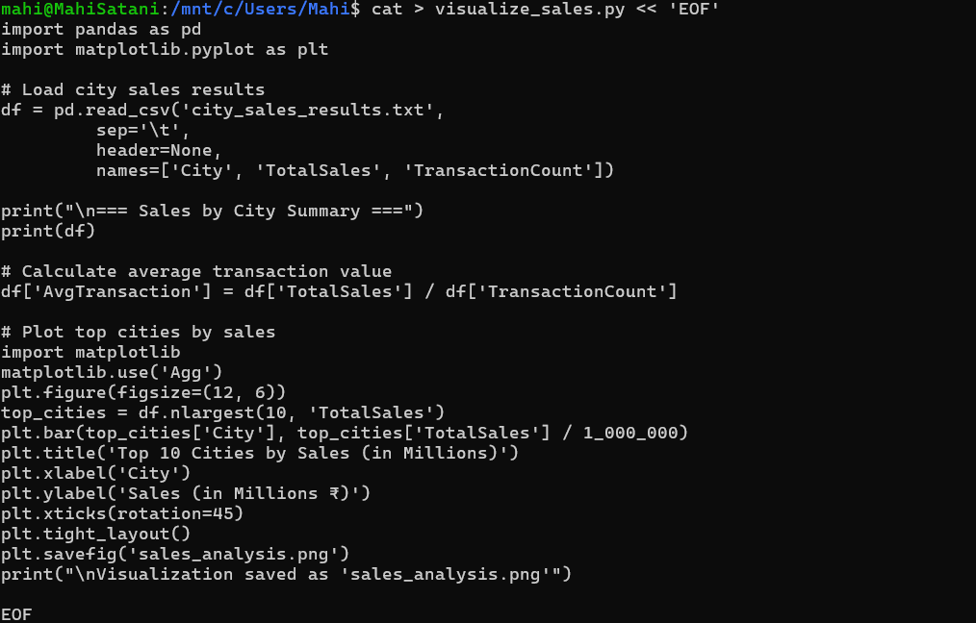

5. Conclusion
The Hadoop Streaming experiment was successfully implemented using Python Mapper and Reducer scripts. A large sales dataset containing 50,000 records was processed using Hadoop MapReduce. City-wise sales, monthly sales trends, and product quantity analysis were performed efficiently. The results were further visualized using Python and Matplotlib. This experiment demonstrated the practical use of Hadoop Streaming for large-scale distributed data processing and analysis.

